MODULE 6

- Capture and analyze ARP packets using Wireshark.
Inspect the ARP request and reply frames when your device attempts to find the router’s MAC address.
Discuss the importance of ARP in packet forwarding.
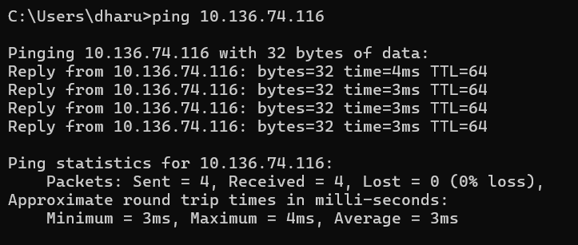
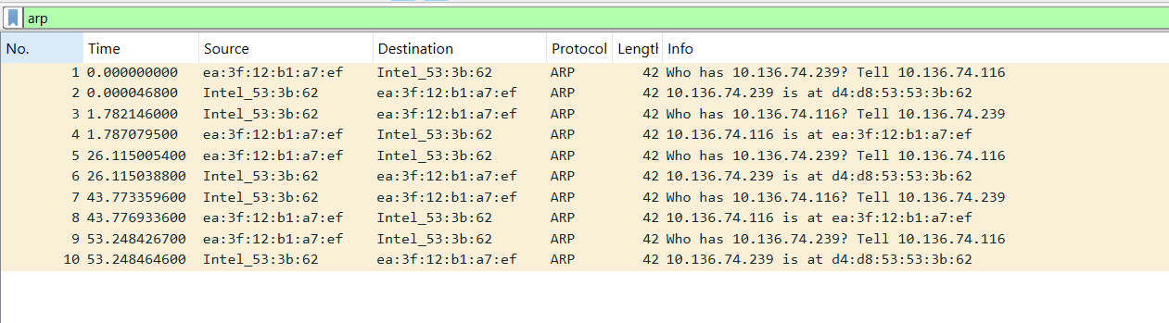
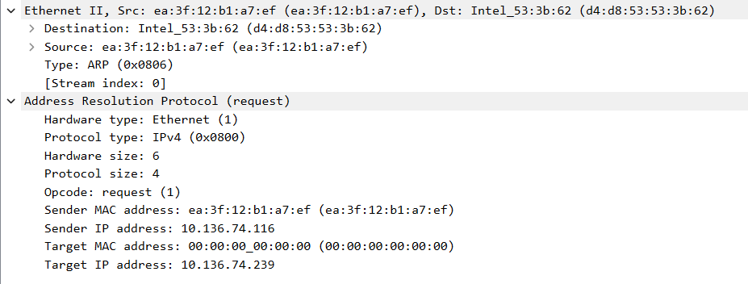
In the above figure, ARP request is sent by the device with IP 10.136.74.116 to find the MAC address of the device with IP 10.136.74.239.
Since the sender does not know the target MAC address, it is set to 00:00:00:00:00:00.
The ARP request is broadcast to all devices in the network.
The request basically means:
"Who has IP address 10.136.74.239? Tell 10.136.74.116"
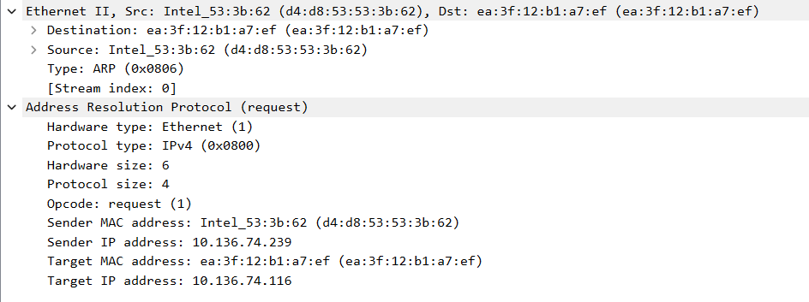
In the above figure, ARP reply is sent by the device with IP 10.136.74.239 to the device 10.136.74.116.
It provides its MAC address so that communication can occur.
The reply basically means:
"10.136.74.239 is at MAC d4:d8:53:53:3b:62"
- ARP is important in packet forwarding because communication in a local network uses MAC addresses, while devices identify each other using IP addresses.
- ARP translates IP addresses into MAC addresses so that Ethernet frames can be delivered to the correct device.
- Without ARP, a device would not be able to find the MAC address of the router or other devices, and packet forwarding would not be possible in a local network.

- Manually configure static routes on a router to direct packets to different subnets. Use the ip route command and verify connectivity using ping and traceroute.

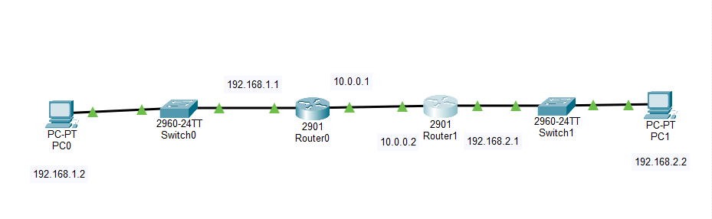

Static routing in Router0:
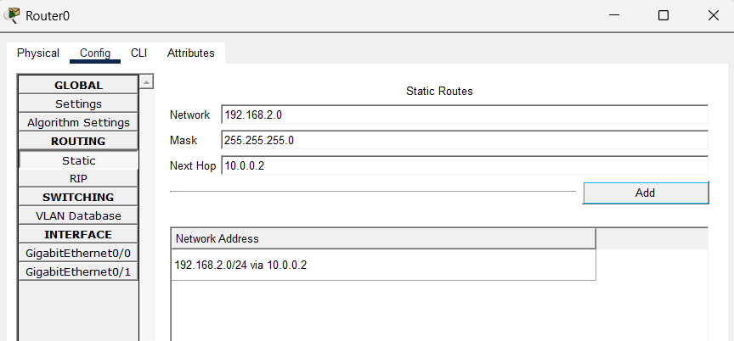
Static routing in Router1:
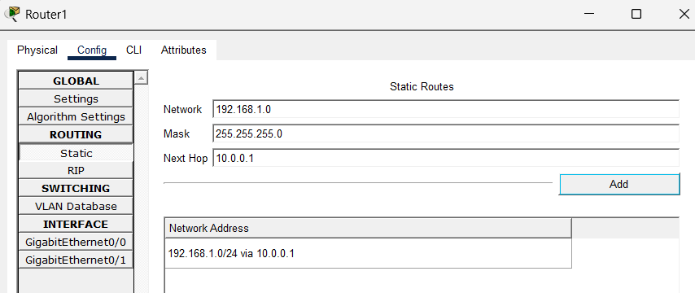
Pinging 192.168.2.2:
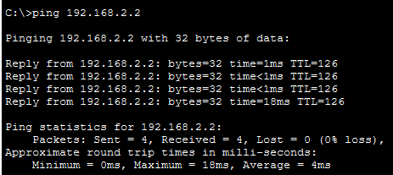

Tracerouting 192.168.2.2:
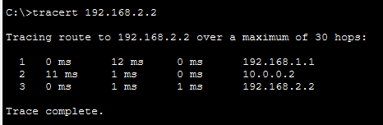
Static routing was successfully configured between two different networks using two routers. IP addresses were assigned to all router interfaces and PCs, and static routes were added to each router to reach the remote network. Connectivity between the two networks was verified using the ping command, which showed successful replies. The traceroute command showed that packets traveled through Router0 and Router1 before reaching the destination network.
- Given a network address of 10.0.0.0/24, divide it into 4 equal subnets. Calculate the new subnet mask. Determine the valid host range for each subnet. Assign IP addresses to devices in Packet Tracer and verify connectivity.
Calculation of new subnet mask:
Network: 10.0.0.0/24
Number of subnets required = 4
/24 = 11111111.11111111.11111111.00000000
Subnets needed = 4,
So 2^n = 4 = 2^2, Therefore, n = 2
/24 + n = /24 + 2 = 26
Therefore subnet mask: /26 = 11111111.11111111.11111111.11000000 = 255.255.255.192
Calculating the range of valid IP addresses for each subnet:
Block size = 256 − 192 = 64
Subnet | Network Address | Valid Host Range | Broadcast
1 | 10.0.0.0/26 | 10.0.0.1 – 10.0.0.62 | 10.0.0.63
2 | 10.0.0.64/26 | 10.0.0.65 – 10.0.0.126 | 10.0.0.127
3 | 10.0.0.128/26 | 10.0.0.129 – 10.0.0.190 | 10.0.0.191
4 | 10.0.0.192/26 | 10.0.0.193 – 10.0.0.254 | 10.0.0.255

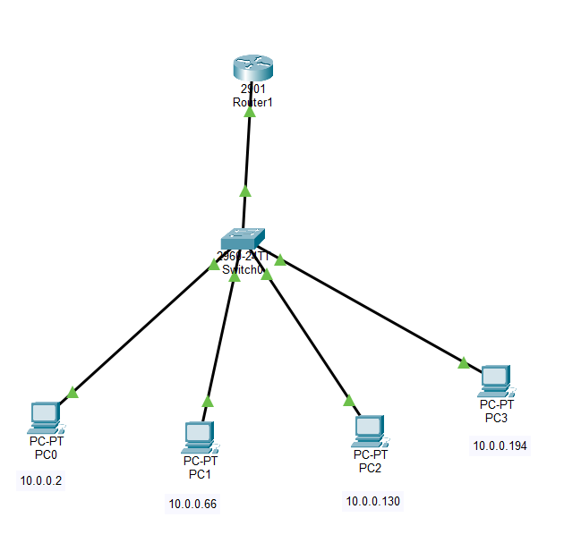

Switch configuration:
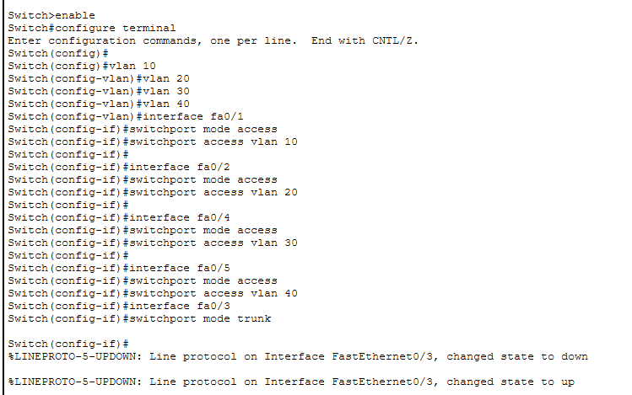
Router Configuration:
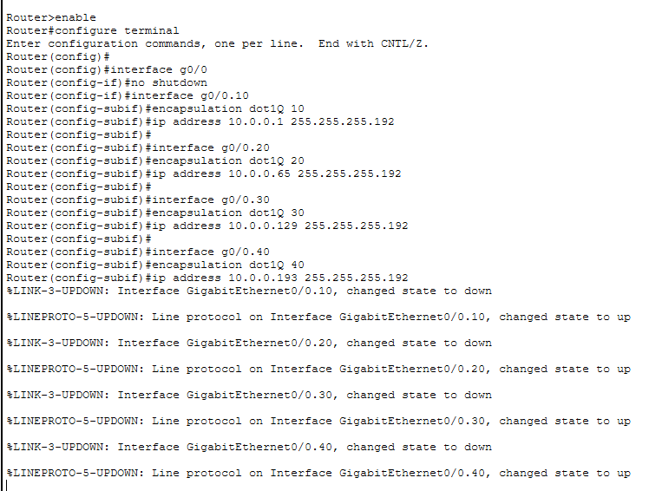
From PC0 pinging PC1, PC2, PC3:
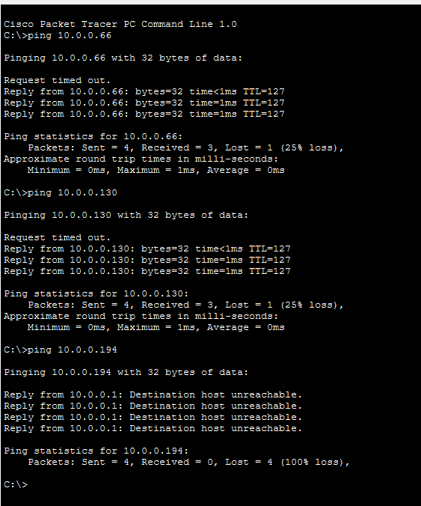

- You are given three IP addresses: 192.168.10.5, 172.20.15.1, and 8.8.8.8.
Identify the class of each IP address.
Determine if it is private or public.
Explain how NAT would handle a private IP when accessing the internet.
Class of each IP Address:
192.168.10.5: Class C - Private
172.20.15.1: Class B - Private
8.8.8.8.: Class A - Public
Private IP addresses cannot be used directly on the internet, so NAT is used. When a private IP device sends data to the internet, the router translates the private IP address into its public IP address. The router keeps the mapping in a NAT table and when the response returns, it translates the public IP back to the private IP and forwards the packet to the correct device.
- In Cisco Packet Tracer, configure NAT on a router to allow internal devices (192.168.1.x) to access the internet. Test connectivity by pinging an external public IP. Capture the traffic in Wireshark and analyze the source IP before and after NAT translation.

CISCO PACKET TRACER:
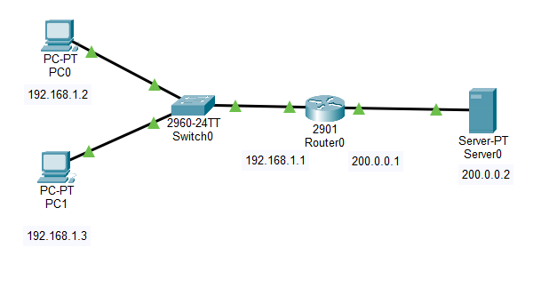

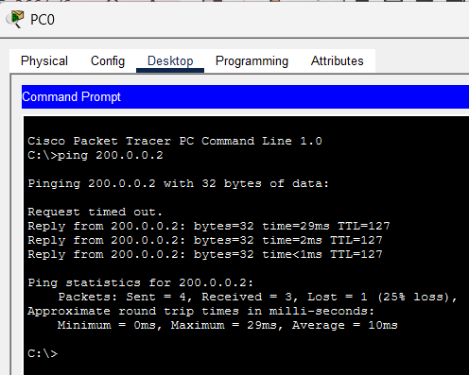

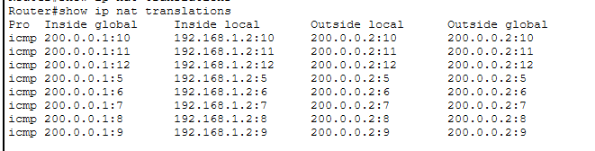
Source IP address before NAT : 192.168.1.2
Source IP address after NAT : 200.0.0.1
NAT translates private IP to public IP.

WIRESHARK:

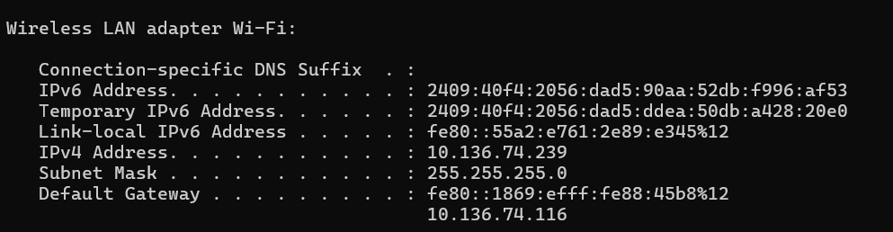

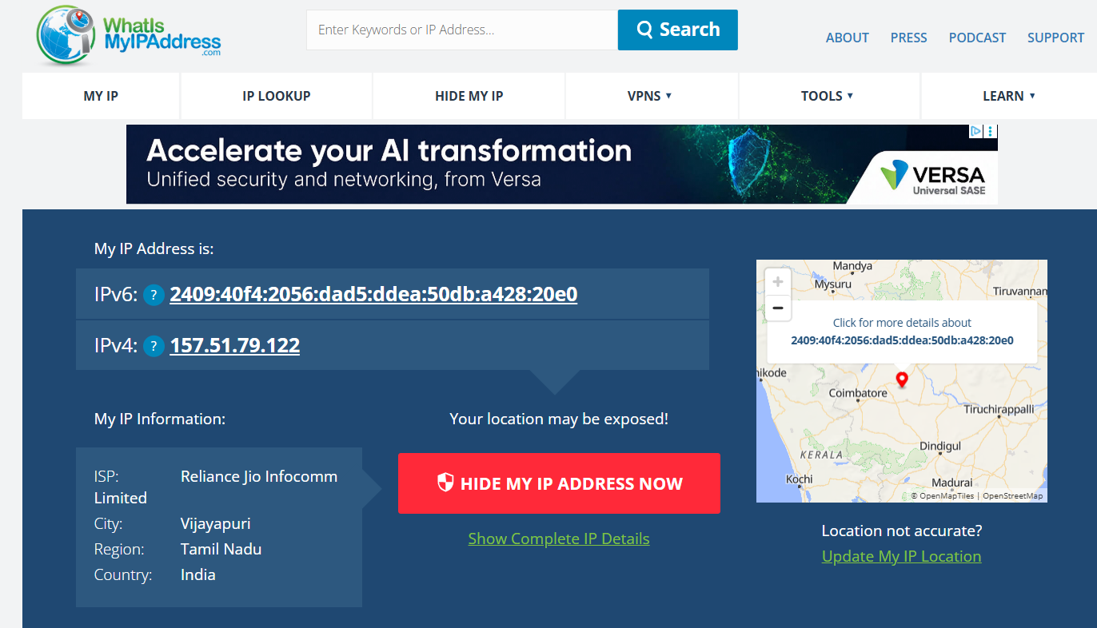

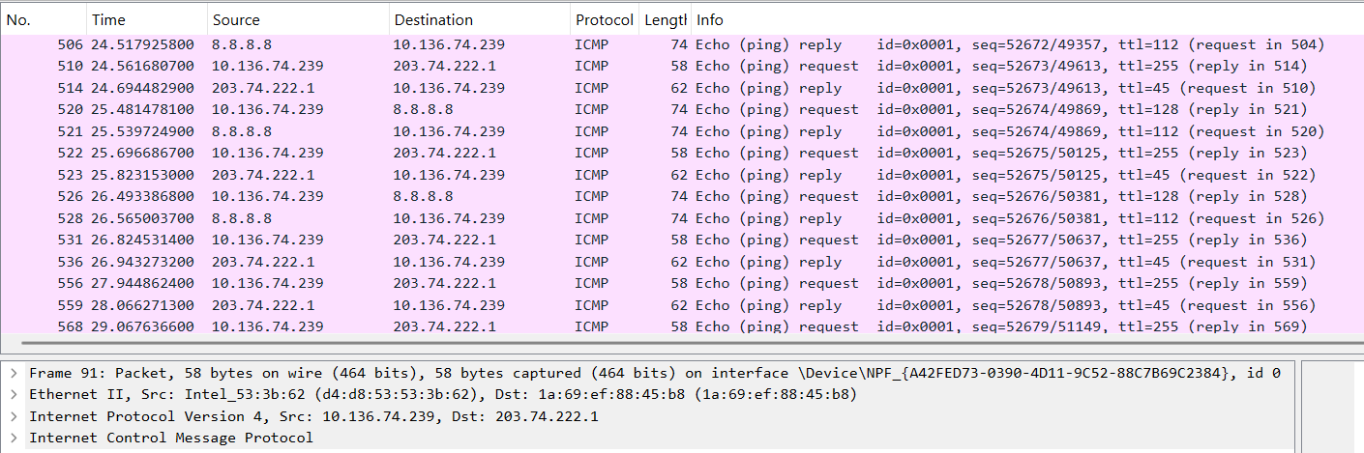

Before NAT | 10.136.74.239 (Private IP address)

After NAT | 157.51.79.122 (Public IP address)

